Deerwalk Institute Of Technology
Database Administration

Lab:

Submitted By: Submitted To:
Name: Sagar Giri Narayan Chalise
Roll No. 205

Date:

Virtual Private Database And policy types

Virtual Private Database (VPD) is a feature of Oracle Database 11g Enterprise Edition, and was introduced in Oracle8i. It is one of the most popular security features in the database. A virtual private database or VPD masks data in a larger database so that only a subset of the data appear to exist, without actually segregating data into different tables, schema or databases. Oracle Virtual Private Database enables us to create security policies to control database access at the row and column level.

Essentially, Oracle Virtual Private Database adds a dynamic WHERE clause to a SQL statement that is issued against the table, view. VPD policies can be simple or complex depending on the security requirements. A simple VPD example might restrict access to data during business hours and a more complex VPD example might read an application context during a login trigger and enforce row level security against the table. No matter how users connect to the protected table (via an application, a Web interface or SQL*Plus), the result is the same.

To implement VPD in oracle, we follow following procedure:

1. Create a arbitrary table, where we assign a policy later:

2. Fill in some dummy data:
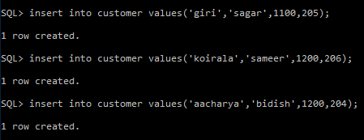

3. Verify that data are present in the newly created table:
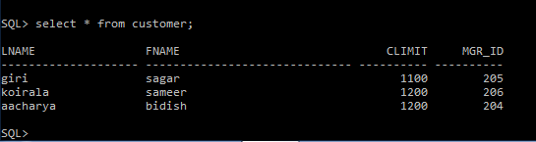

4. Now we create a VPD policy and function, so that when a user executes select query, only the data of particular manager id is shown in the table.

The code for the function is written in the SQL file and is imported in the sql console.

PolicyFucntion.sql

CREATE OR REPLACE FUNCTION orders(
schema_var IN VARCHAR2,
table_var IN VARCHAR2
)
RETURN VARCHAR2
IS
return_val VARCHAR2 (400);
BEGIN
return_val := 'mgr_id = 205';
RETURN return_val;
END orders;
/

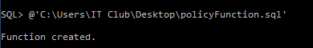
The function is then imported:

5. Now we write a VPD policy.

VpdPolicy.sql
BEGIN
DBMS_RLS.ADD_POLICY(
object_schema => 'system',
object_name => 'customer',
policy_name => 'secure',
policy_function => 'orders',
statement_types => 'SELECT');
END;
/

and then import it:

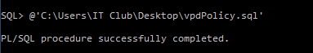

6. Now, when we execute select command, we can only view the details of member with MGR_ID=205.
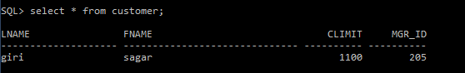

7. We can drop the policy and function using DROP command. After dropping the function and policy, user can view all the data in the table.
